# Multiple Linear Regression

**Instructions**

Please share your answers filled in this word document. Submit code files wherever applicable.

Please ensure you update all the details:

**Name:**

**Instructions:**

Please share your answers filled in-line in the word document. Submit code separately wherever applicable.

Please ensure you update all the details:

**Name: _____________ Batch ID:** ___________

**Topic: Multilinear Regression**

**Grading Guidelines:**

**1. An assignment submission is considered complete only when correct and executable code(s) are submitted along with the documentation explaining the method and results. Failing to submit either of those will be considered an invalid submission and will not be considered for evaluation.**

**2. Assignments submitted after the deadline will affect your grades.**

**Grading:**

|  |  |  |  |  |  |
| --- | --- | --- | --- | --- | --- |
| **Ans** | **Date** |  |  | **Ans** | **Date** |
| Correct | On time | A | 100 |  |  |
| 80% & above | On time | B | 85 | Correct | Late |
| 50% & above | On time | C | 75 | 80% & above | Late |
| 50% & below | On time | D | 65 | 50% & above | Late |
|  |  | E | 55 | 50% & below |  |
| Copied/No Submission |  | F | 45 |  |  |

* **Grade A: (>= 90):** When all assignments are submitted on or before the given deadline.
* **Grade B: (>= 80 and < 90):** 
  + When assignments are submitted on time but less than 80% of problems are completed.

(OR)

* + All assignments are submitted after the deadline.
* **Grade C: (>= 70 and < 80):** 
  + When assignments are submitted on time but less than 50% of the problems are completed.

(OR)

* + Less than 80% of problems in the assignments are submitted after the deadline.
* **Grade D: (>= 60 and < 70):**
  + Assignments submitted after the deadline and with 50% or less problems.
* **Grade E: (>= 50 and < 60):** 
  + Less than 30% of problems in the assignments are submitted after the deadline.

(OR)

* + Less than 30% of problems in the assignments are submitted before the deadline.
* **Grade F: (< 50):** No submission (or) malpractice.

1. **Business Problem**
   1. **What is the business objective?**
   2. **Are there any constraints?**
2. **Work on each feature of the dataset to create a data dictionary as displayed in the below image:**

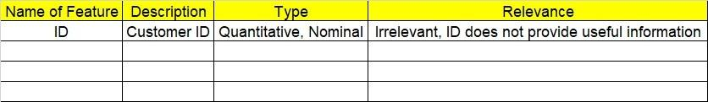

**2.1 Make a table as shown above and provide information about the features such as its data type and its relevance to the model building. And if not relevant, provide reasons and a description of the feature.**

1. **Data Pre-processing**

**3.1 Data Cleaning, Feature Engineering, etc.**

**3.2 Outlier Treatment.**

1. **Exploratory Data Analysis (EDA):**
   1. **Summary.**
   2. **Univariate analysis.**
   3. **Bivariate analysis.**
2. **Model Building**
   1. **Build the model on the scaled data (try multiple options).**
   2. **Perform Multi linear regression model and check for VIF, AvPlots, Influence Index Plots.**
   3. **Train and Test the data and compare RMSE values. Tabulate R-Squared and RMSE values for different models in the documentation and provide an explanation.**
   4. **Briefly explain the model output in the documentation.**
   5. **Tune the model and improve its accuracy.**
3. **Write about the benefits/impact of the solution - in what way does the business (client) benefit from the solution provided?**

**Problem Statements: -**

1. An analytics company has been tasked with the crucial job of finding out what factors affect a startup company and if it will be profitable or not. For this, they have collected some historical data and would like to apply multilinear regression to derive brief insights into their data. Predict profit, given different attributes for various startup companies.

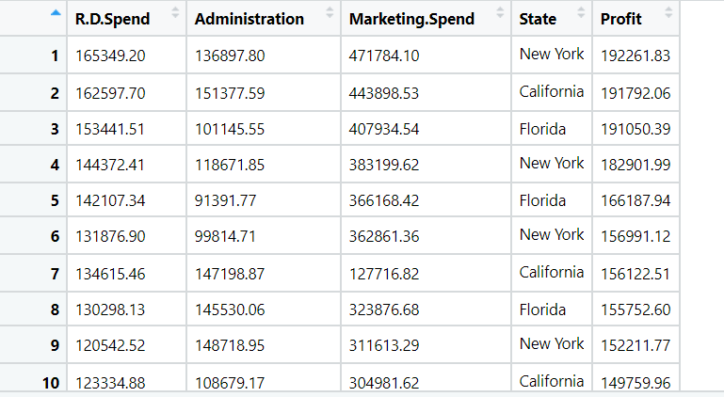

1. Perform multilinear regression with price as the output variable and document the different RMSE values.

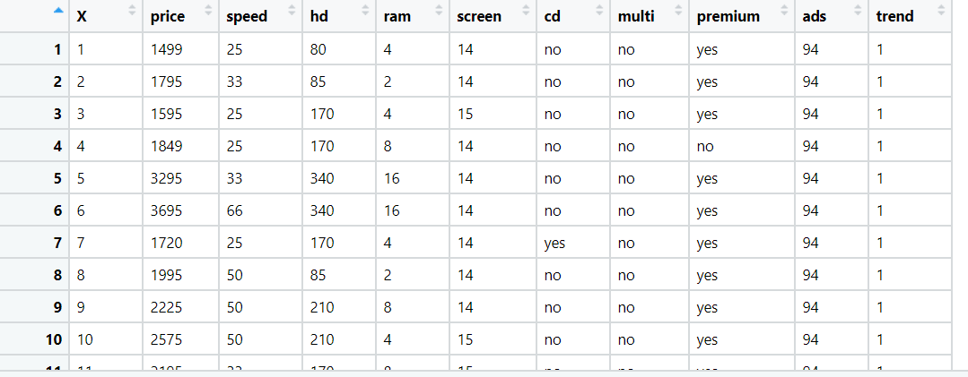

1. An online car sales platform would like to improve its customer base and their experience by providing them an easy way to buy and sell cars. For this, they would like an automated model which can predict the price of the car once the user inputs the required factors. Help the business achieve their objective by applying multilinear regression on the given dataset. Please use the below columns for the analysis purpose: price, age_08_04, KM, HP, cc, Doors, Gears, Quarterly_Tax, and Weight.

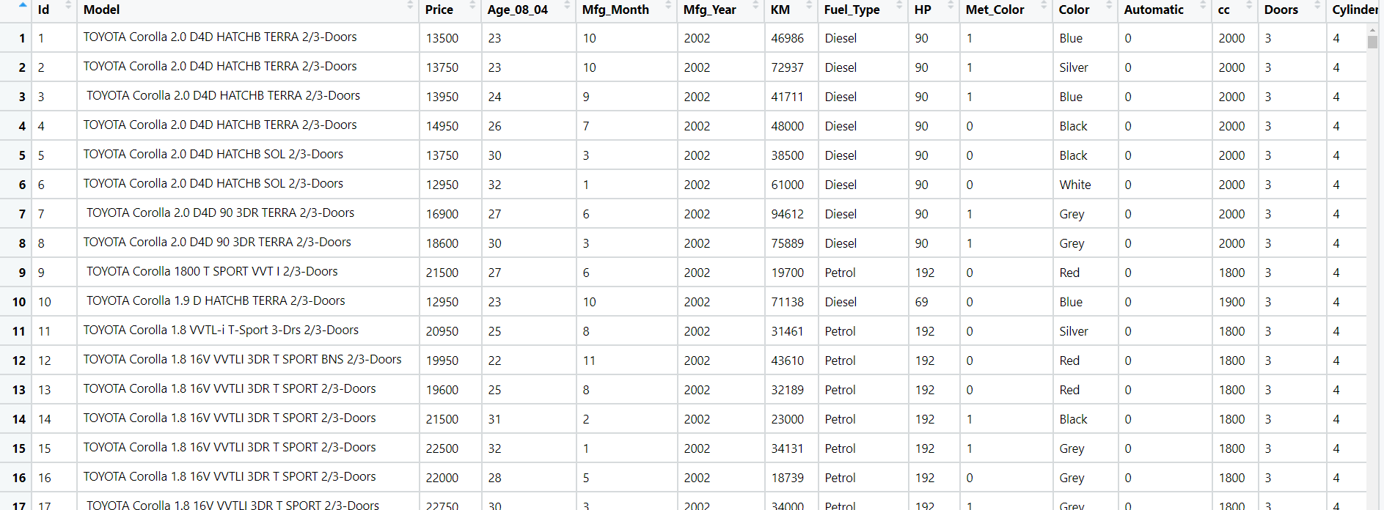

1. With the growing consumption of avocados in the USA, a freelance company would like to do some analysis on the patterns of consumption in different cities and would like to come up with a prediction model for the price of avocados. For this to be implemented, build a prediction model using multilinear regression and provide your insights on it.

Snapshot of the dataset is given below: -

